Library

🌟 Definition
# Source: AI Source: Provided by: [Data Path: Persons Table -> ID Column: 1, Name_En Column: Motasem Essam] -> From: [ChatGPT] on [6/7/2026]
A Library is a collection of pre-written code (functions, classes, modules, and utilities) that developers can reuse in their applications instead of writing everything from scratch.
A library provides specific functionality that your code can call when needed.

🎯 Simple Definition
# Source: AI Source: Provided by: [Data Path: Persons Table -> ID Column: 1, Name_En Column: Motasem Essam] -> From: [ChatGPT] on [6/7/2026]
Library = Reusable Code Written by Someone Else
Instead of building a feature yourself, you use a library that already solves the problem.

🧠 Real-World Analogy
# Source: AI Source: Provided by: [Data Path: Persons Table -> ID Column: 1, Name_En Column: Motasem Essam] -> From: [ChatGPT] on [6/7/2026]
Imagine building a house.
Without a Library
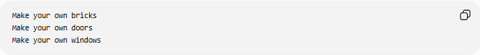
Make your own bricks
Make your own doors
Make your own windows

With a Library
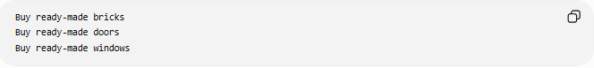
Buy ready-made bricks
Buy ready-made doors
Buy ready-made windows
You save time and effort.

🔄 How a Library Works
# Source: AI Source: Provided by: [Data Path: Persons Table -> ID Column: 1, Name_En Column: Motasem Essam] -> From: [ChatGPT] on [6/7/2026]
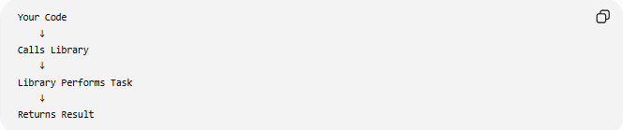
Your Code
↓
Calls Library
↓
Library Performs Task
↓
Returns Result
Unlike a framework, you are in control and decide when to call the library.

📚 Example
# Source: AI Source: Provided by: [Data Path: Persons Table -> ID Column: 1, Name_En Column: Motasem Essam] -> From: [ChatGPT] on [6/7/2026]
PHP JSON Library
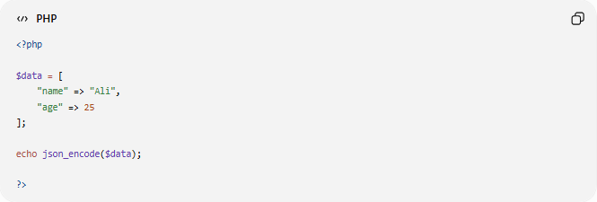
<?php
$data = [
"name" => "Ali",
"age" => 25
];
echo json_encode($data);
?>
Output:
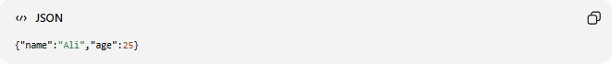
{"name":"Ali","age":25}
Here, json_encode() is a library function.

🧩 What Can a Library Contain?
# Source: AI Source: Provided by: [Data Path: Persons Table -> ID Column: 1, Name_En Column: Motasem Essam] -> From: [ChatGPT] on [6/7/2026]
A library may contain:
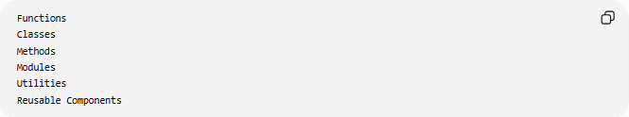
Functions
Classes
Methods
Modules
Utilities
Reusable Components

📂 Types of Libraries

1️⃣ Database Libraries
# Source: AI Source: Provided by: [Data Path: Persons Table -> ID Column: 1, Name_En Column: Motasem Essam] -> From: [ChatGPT] on [6/7/2026]
Used to connect and work with databases.
Examples:
- PDO (PHP Data Objects)
- MySQLi
Example:
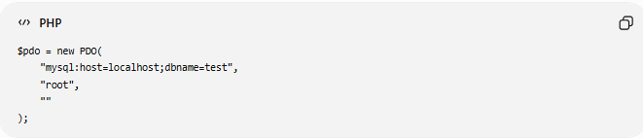
$pdo = new PDO(
"mysql:host=localhost;dbname=test",
"root",
""
);

2️⃣ HTTP Libraries
# Source: AI Source: Provided by: [Data Path: Persons Table -> ID Column: 1, Name_En Column: Motasem Essam] -> From: [ChatGPT] on [6/7/2026]
Used to communicate with APIs and websites.
Examples:
- cURL
- Guzzle
Example:
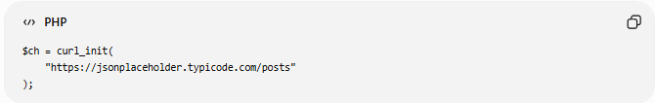
$ch = curl_init(
"https://jsonplaceholder.typicode.com/posts"
);

3️⃣ JSON Libraries
# Source: AI Source: Provided by: [Data Path: Persons Table -> ID Column: 1, Name_En Column: Motasem Essam] -> From: [ChatGPT] on [6/7/2026]
Used to process JSON data.
Example:
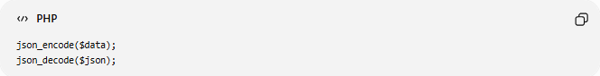
json_encode($data);
json_decode($json);

4️⃣ UI Libraries
# Source: AI Source: Provided by: [Data Path: Persons Table -> ID Column: 1, Name_En Column: Motasem Essam] -> From: [ChatGPT] on [6/7/2026]
Used to build user interfaces.
Examples:
- React
- jQuery

5️⃣ Data Analysis Libraries
# Source: AI Source: Provided by: [Data Path: Persons Table -> ID Column: 1, Name_En Column: Motasem Essam] -> From: [ChatGPT] on [6/7/2026]
Examples:
- NumPy
- Pandas

6️⃣ Testing Libraries
# Source: AI Source: Provided by: [Data Path: Persons Table -> ID Column: 1, Name_En Column: Motasem Essam] -> From: [ChatGPT] on [6/7/2026]
Examples:
- PyTest
- Assertion libraries

🌍 Real-World Examples
# Source: AI Source: Provided by: [Data Path: Persons Table -> ID Column: 1, Name_En Column: Motasem Essam] -> From: [ChatGPT] on [6/7/2026]
Sending Emails
Without a library:
Write SMTP protocol yourself
With a library:
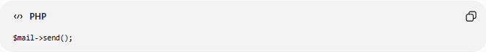
$mail->send();

Making HTTP Requests
Without a library:
Build HTTP communication manually
With cURL:
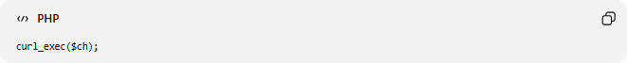
curl_exec($ch);

Working with Dates
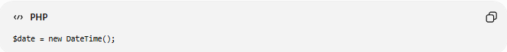
$date = new DateTime();
Uses PHP's date library.

📊 Library vs Framework
# Source: AI Source: Provided by: [Data Path: Persons Table -> ID Column: 1, Name_En Column: Motasem Essam] -> From: [ChatGPT] on [6/7/2026]
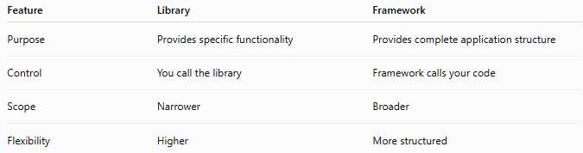
Feature | Library | Framework
Purpose | Provides specific functionality | Provides complete application structure
Control | You call the library | Framework calls your code
Scope | Narrower | Broader
Flexibility | Higher | More structured

Library
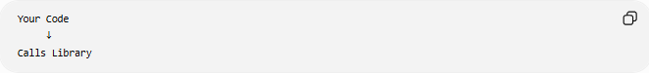
Your Code
↓
Calls Library
Example:
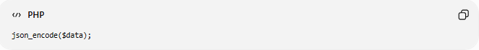
json_encode($data);

Framework
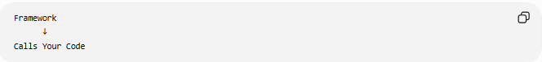
Framework
↓
Calls Your Code
Example:
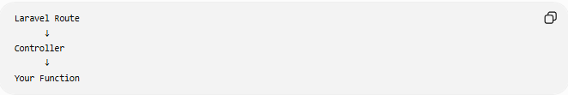
Laravel Route
↓
Controller
↓
Your Function

📊 Library vs Code
# Source: AI Source: Provided by: [Data Path: Persons Table -> ID Column: 1, Name_En Column: Motasem Essam] -> From: [ChatGPT] on [6/7/2026]
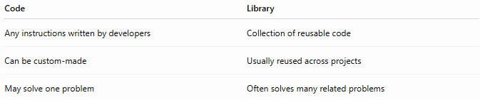
Code | Library
Any instructions written by developers | Collection of reusable code
Can be custom-made | Usually reused across projects
May solve one problem | Often solves many related problems

Relationship
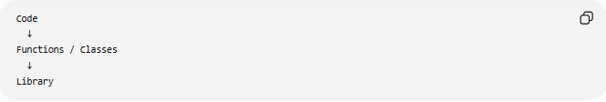
Code
↓
Functions / Classes
↓
Library
A library is built from code.

🛠️ Popular Libraries
# Source: AI Source: Provided by: [Data Path: Persons Table -> ID Column: 1, Name_En Column: Motasem Essam] -> From: [ChatGPT] on [6/7/2026]
PHP
- cURL
- PDO
- Guzzle
JavaScript
- React
- jQuery
- Lodash
Python
- NumPy
- Pandas
- Requests

✅ Advantages of Libraries
# Source: AI Source: Provided by: [Data Path: Persons Table -> ID Column: 1, Name_En Column: Motasem Essam] -> From: [ChatGPT] on [6/7/2026]
- Faster development
- Less code to write
- Reusable solutions
- Community-tested code
- Easier maintenance

❌ Disadvantages of Libraries
# Source: AI Source: Provided by: [Data Path: Persons Table -> ID Column: 1, Name_En Column: Motasem Essam] -> From: [ChatGPT] on [6/7/2026]
- Dependency on external code
- Learning curve
- Compatibility issues
- Possible performance overhead

🧠 Simple Analogy
# Source: AI Source: Provided by: [Data Path: Persons Table -> ID Column: 1, Name_En Column: Motasem Essam] -> From: [ChatGPT] on [6/7/2026]
Think of cooking.
Without a Library
Make everything from scratch
With a Library
Use ready-made ingredients
The library provides reusable pieces so you can focus on building your application.

🧭 Summary
# Source: AI Source: Provided by: [Data Path: Persons Table -> ID Column: 1, Name_En Column: Motasem Essam] -> From: [ChatGPT] on [6/7/2026]
A Library is a collection of reusable code that provides specific functionality such as database access, HTTP requests, JSON processing, user interface components, testing tools, or data analysis features. Developers call libraries when needed, allowing them to build software faster and avoid rewriting common functionality. Unlike frameworks, libraries do not control the application flow—you remain in control of when and how they are used.

